2026 Annual General Meeting

Location: Lazar House
Date: Thursday 26th February 2026
Time: 13:00

Order of events

Introductions and opening

Speeches and videos:

Sarah – volunteering at the Post Office (live speech)
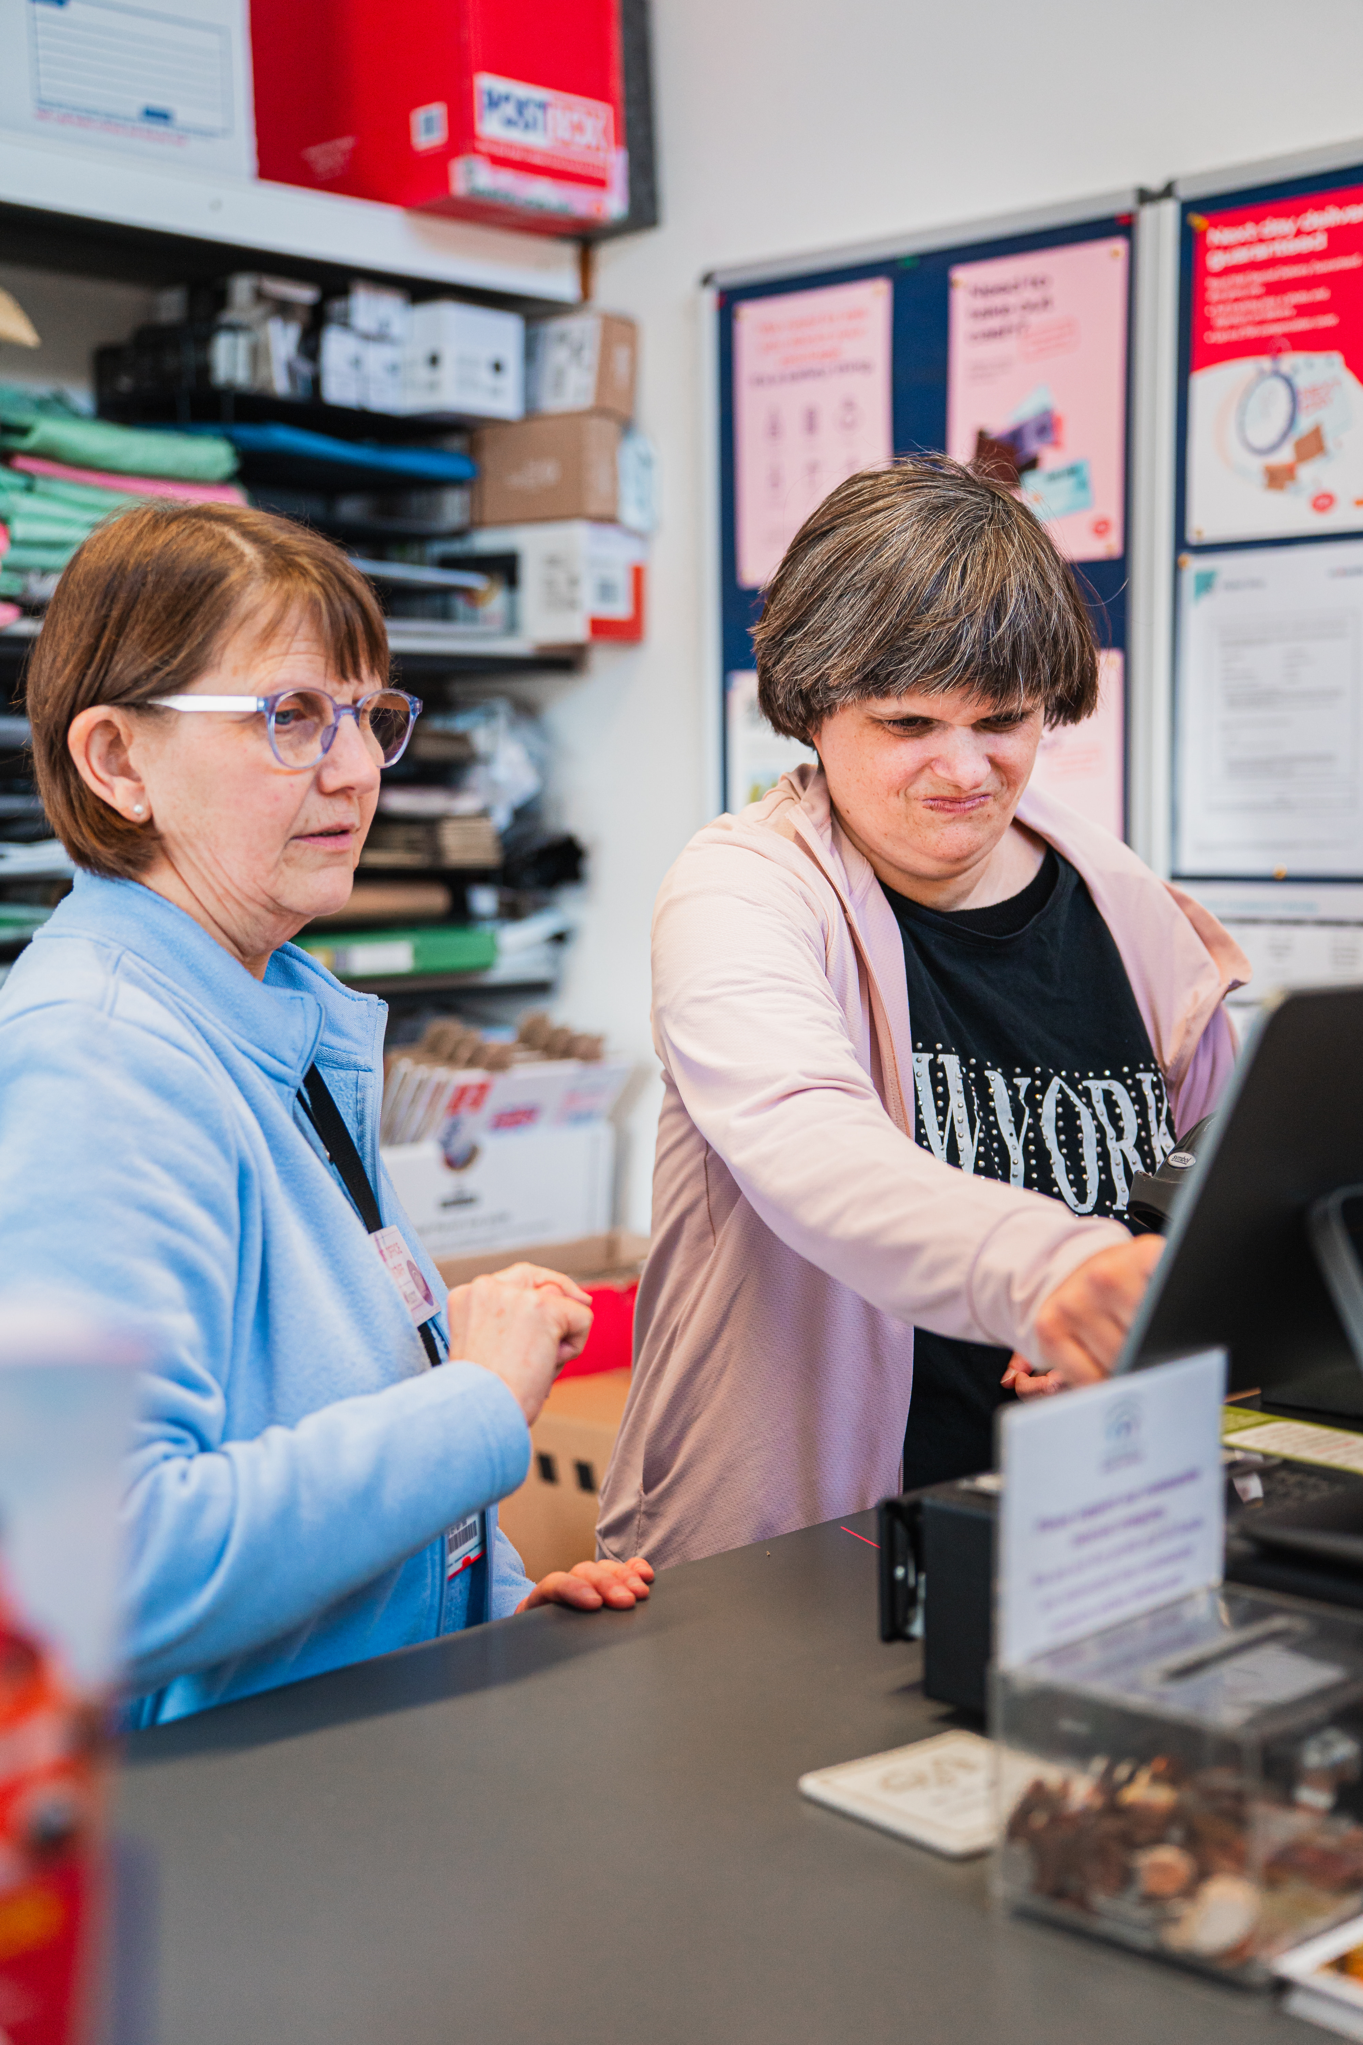 | My name is Sarah and I have voluntary job at Hethersett Post Office. I’ve been volunteering here since April 2023.  I get the number 14 bus from castle meadow to work. I did some travel training to begin with to help me get to work but it didn’t take me long because it’s a pretty straight forward route.  I serve customers stationery and cards on the till and also tidy the cards. I also do the door duty, which means when a little bell goes I need to and answer the door. I also have the volunteer iPhone, which lets me know when a customers ringing the bell.  I love my job. It has given me lots of confidence.

Amy – working at the Assist café (live speech)
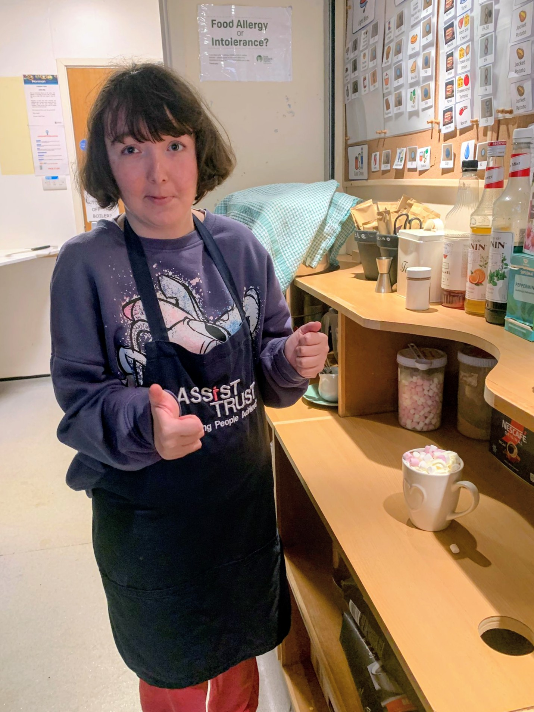 | My name is Amy. I’m going to talk about working at the Norman Centre Café.  I catch the bus to the Norman Centre with staff and other members.  I serve the customers. I use the till. I make the drinks. I do the washing up and clear up.  I like doing all of it.

Lauren – being a new member at Assist (live speech)
 | Hello, my name is Lauren Elvin. I am a new member at Lazar House.  I love everything at Assist Trust;  I love doing mosaics with Poppy.  I love dancing with Lauren Rackham.  I love going to work on Thursdays to Mind charity shop. I do lots of lovely work there. I price the books and DVDs and I have sorted out the shoes.  I love going out and going to Waterstones to look at the picture books.  I love laughing with all my new friends. I look after them.  I love having my lunch at Colegate and making friends there. I feel so confident at Assist.

Susan – getting and keeping a paid job (video)
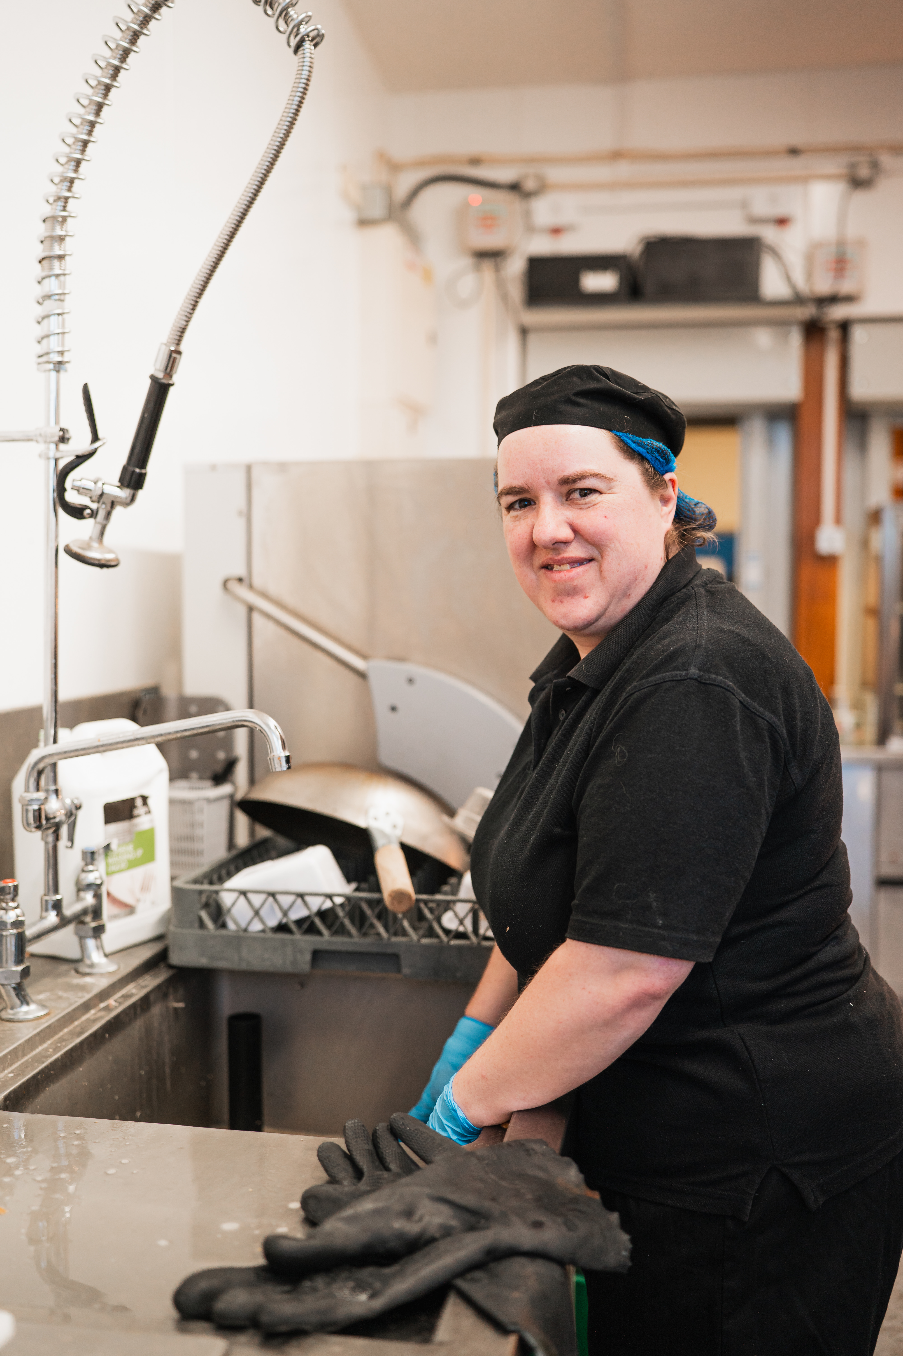 | Susan tells us about her paid job role in the kitchens at Long Stratton High School.  This video is available to watch again on YouTube. Search ‘Assist Trust Susan’s paid job role at Long Stratton High School’

Jamie (An interview with)

Q. What’s your favourite thing to do at Assist?
A. Getting out and about
Q. What places do you like to go?
A. Wroxham, museums, the city
Q. What was your favourite thing to see at the Castle Museum?
A. Stuffed birds and the paintings
Q. What’s your favourite café to go to and what do you like to order?
A. A café in Sheringham. I like a cup of tea, a muffin or a sausage roll.
Q. Is there anywhere you’d like to go in the future?
A. I’d like to work at the meeting place café and do a gardens group.

Ali – Volunteering at St Georges Church (live speech and video)
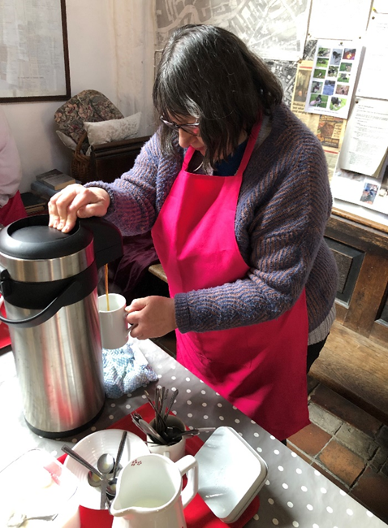 | My Name is Ali Watson. I want to tell you about my job at St Georges Church.  I’ve become more confident since having a job. I work with another member, Jessica, and we work well as a team.  I’ve worked at St Georges church for a year now. I’ve got to know the other volunteers and what the regulars like to drink.  I hope you enjoy the video about my work placement.  This video is available to watch again on YouTube. Search ‘Assist Trust Ali’s voluntary work placement at St Georges church’

Gym Group (video)
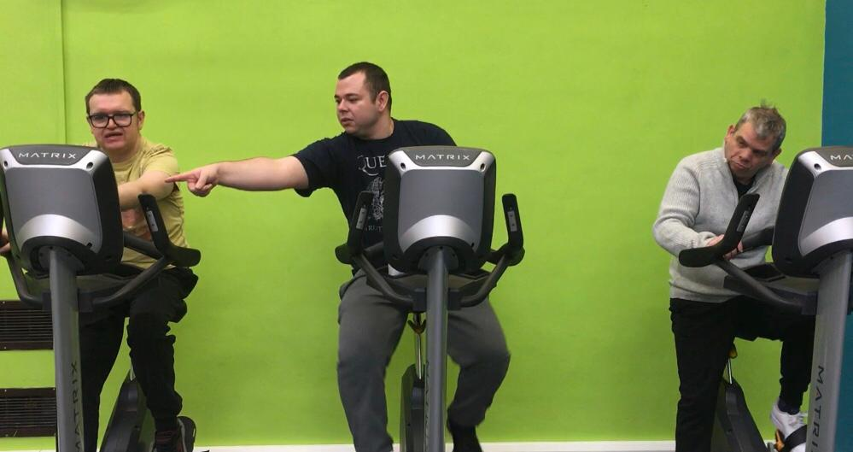
The members tell us all about the gym group.
This video is available to watch again on YouTube. Search ‘Assist Trust gym group’

Louis – getting around the community and the Assist Gardens (an interview with…)
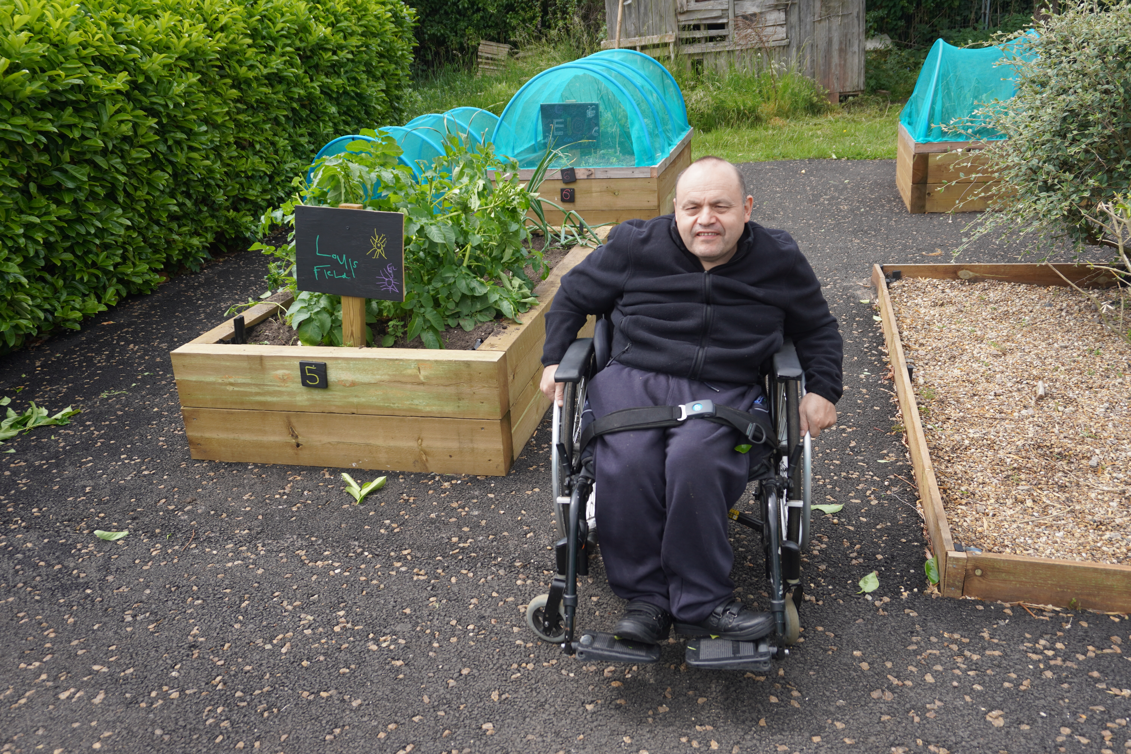 | Q. Would you like to tell everyone who you are?  A. My name is Louis  Q Did you want to tell people what you do on a Friday morning from Assist?  A. Description of Out and About Group  Q. What do you think of the new Accessible van that Assist now has?  A. Comments about the new van  Q.What do you think of the new paths at the Gardens?  A. Comments about new hard surfacing areas around the plots  Q. Did you want to say something about the staff at Assist?  A. Thank you to the staff group

Jess – Skills and Employment pathway success! (video)
 | Jess tells us about her confidence building and work skills journey since starting at Assist Trust.  This video is available to watch again on YouTube. Search ‘Assist Trust Jess’s work skills journey’’

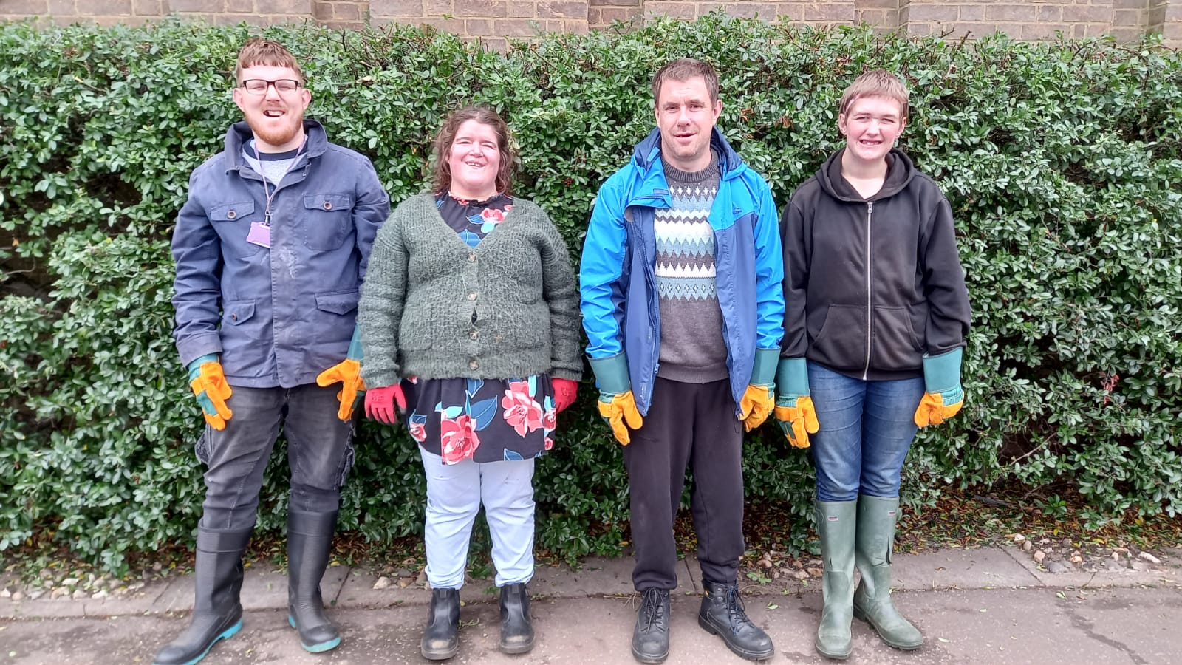
Michael from St Francis Church (live speech)
Michael from St Francis Church tells us all about the Assist volunteers.

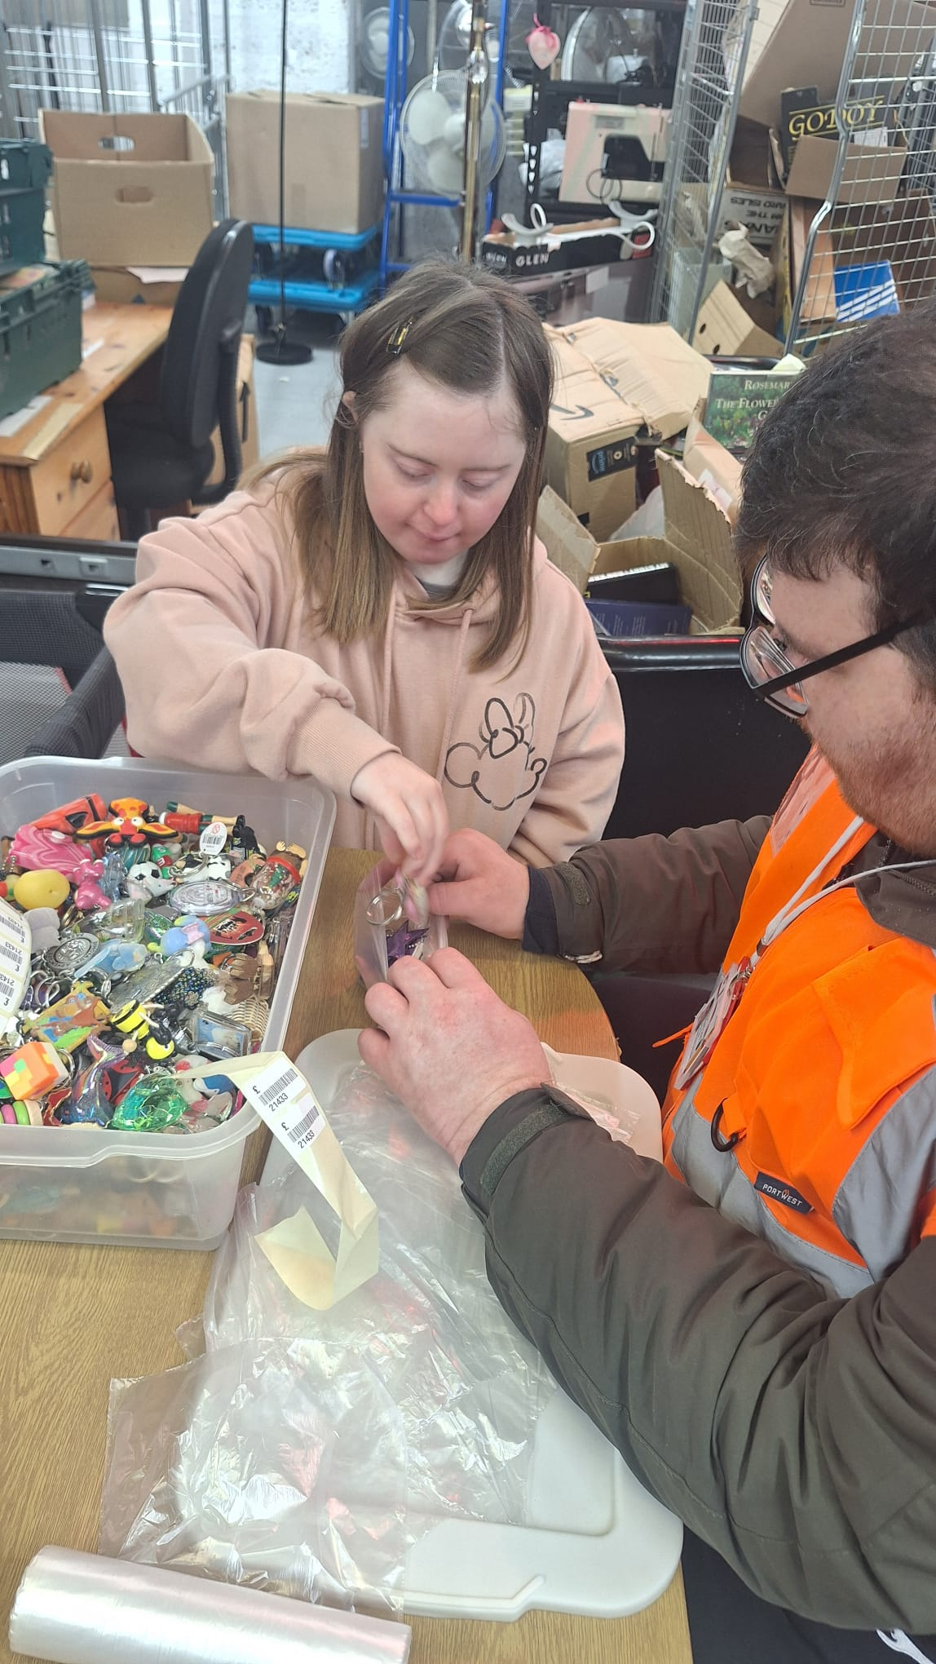
Volunteering at Pricilla Bacon Lodge (video)
The Volunteering in the Community Group tell us about their group work placement.
This video is available to watch again on YouTube. Search ‘Assist Trust Volunteering at Priscilla Bacon Lodge’

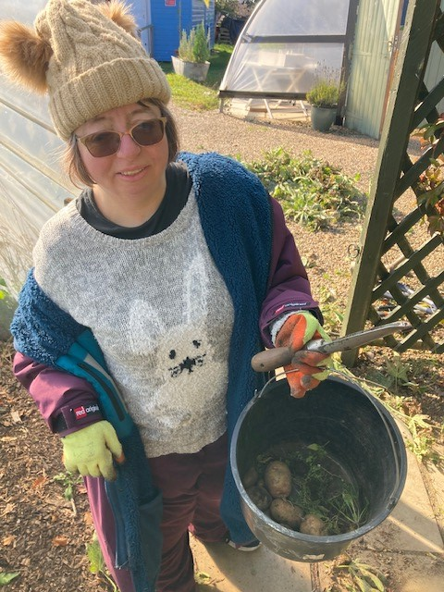
Hayley – volunteering at the Big C (live speech)
My name is Hayley.
I have been coming to Assist for a long time.
I volunteer at the Big C charity shop.
I like hanging all the clothes up.
I enjoy gardening, we have been raking leaves.
I love coming to Assist and seeing my friends.
I love going out with groups and going on the bus.
I am very happy here.

Round up of the year and looking ahead – Richard Ward (CEO)

Thank you for your support, confirming Trustees and Assist accounts– comments from Bob Holderness (Chair of the Trustees)

Please stay for refreshments and to chat with our members and staff

Thank you for attending!

Assist 2026 dates for the diary:

Events:
Friday 20th March – Members Pizza and movie night
Saturday 13th June – Assist Trust Festival (everybody welcome!)
Friday 4th September – Members Quiz and Chips night
Friday 11th December – Members Christmas party

Staff Training Days:
Thursday 12th March
Wednesday 10th June
Tuesday 6th October
Monday 7th December

