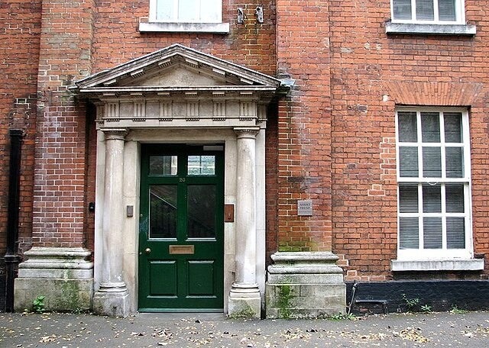
Hello from the newsletter group. Our newsletter has now come to an end; we hope you enjoy our final newsletter.

Written and edited by James, Sally, Bradley, Amy, Tina, Lizzie, Maverick, Susan and Kerry.
COLEGATE NEWS

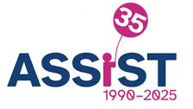

What was your favourite advert when you were young?
- Tina: Milky bar advert "The milky bars are on me."
- Amy: Recent advert of the little girl buying chocolates for her Mum with button and a little dinosaur toy.
- Susan: Spoke about advert for Cadburies Chocolate including a gorila playing the drums along to Phill Collins song
- Lizzie: Fairy liquid advert with a little boy waiting to make a rocket out of the washing up bottle.

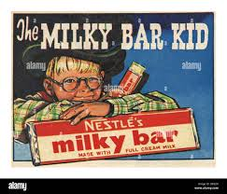

Waterloo Park Review
Toilets: Yes - No toilet paper in the ladies but the men’s were nice.
Accessibility: The main walk is accessible the raised walks did have ramps
Grounds: Great, lots of plants and flowers and really nice walkways. Lots of open spaces for playing and dogs as well as a fountain and shaded areas.
Facilities: Really nice Café, a little pricy but otherwise nice and is
also a charity.
Upkeep : Very neat and tidy. Looked clean and well kept

By the Reviewing Parks Group

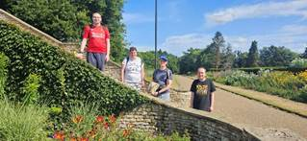

COLEGATE NEWS

Celebration of 35 years of Assist Trust at the Forum.

On the 16th of August 2025. The Assist Trust celebrated their 35th anniversary at the forum. This was run from 10am until 3pm. This involved different stalls and displays. This was well-attended by members, their families, friends and general public.

Displays at the event as told by the members;

- Richard Ward opened the event with a speech.
- No limits did 2 displays. The first being with 10 members from Lazar and Colegate. The second show included members and staff dancing to Celebration from Cool in the Gang.
- Inclusive Sports with Epic Norfolk.
- Oak Circus did circus skills workshop.
- Music Finale by Black Dog Music Project.

Outside at the Forum
- The Heath Gardens had a display Garden named the Garden of thought. They also had a stall which sold cards, fridge magnets, large and small magnets along with a tombola where people could either win or buy plants grown at the garden. Susan Hughes won 2 plants and was given an extra one.
- Stall offering hand and arm massages with volunteers from Lush.

Inside the Forum
- Craft stall where people could decorate a box to make a Cress head. Which came with cotton wool, Cress seed and instructions. Along with make your own book mark where people could either write or take pre written notes and decorate them.
- Communal arts group where people made their own flowers and wrote their own messages on them before sticking this to the giant Number 35.
- Information and Communication stall giving out information about Assist Trust with leaflets and booklets. Sally got 2 pens at.
- A fantastic photo display with of most of the members with each of them writing a small piece under them.

COLEGATE NEWS

Shop or service reviewed | 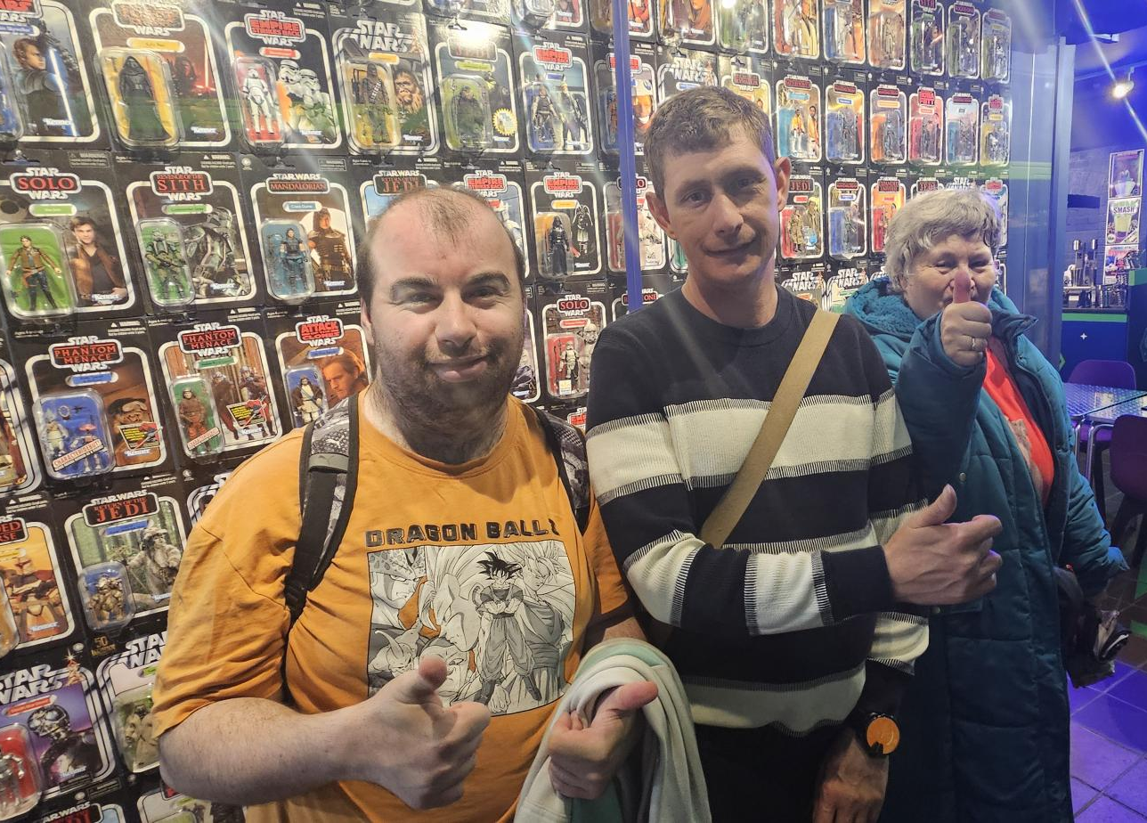  Cosmic Jos 25 Bedford St, Norwich NR2 1AG
Arrival or Greeting | The staff greeted us in a very friendly but professional way and were very welcoming.
Accessibility | The ground the floor is accessibly however, to get to the Café you needed to go down some stairs, we couldn’t see any chair lifts or other way for wheelchair users to access the space. We understand space is limit so this might not be a viable option.
Staff interactions | Lots of staff available. We were served by Aaron who was very happy to talk about the menu and answer any questions we had. Aaron was very friendly, offering lots of time for us to order and making sure to listen carefully to the customers who have communication needs. We were also served at the tills with the assistant (we didn’t manage to catch his name) again being professionally friendly and very knowledgeable about the product and the customer’s needs.
Service Quality | We had a range of hot and cold drinks and some cakes and chocolate. The hot drinks were great and offered good value for money.  We also purchased a collectable card set which was of a good standard and competitive price.
Store or service cleanliness and ambience | The store and Café was decorated very well, lots of lovely things to look and some great art on the walls. The lighting was great with everyone being able to look at the menus with ease. Although the shop and café area is very full and brightly decorated everything looks super clean and tidy, especially the Café area.  The staff were all wearing uniforms and could be clearly identified, looking very smart and professional.
What impressed us | The quality and variety of the shop products, as well as the friendliness and understanding of the staff team.
What could be improved | Just the disabled access for the basement level, otherwise its lovely shop/café and we will most certainly visit again.
 | By The Community Review group
Response from Cosmic Jo’s:
Dear Leah, sorry for the late reply. We were so happy to see this, it really means a lot.

We are aware of the disability access issues. It was something we tried to resolve when taking on the lease, but unfortunately we couldn't find a financially viable solution. The shop is Grade II listed, and so we're not allowed to make alterations to the fabric of the building and no stair lift would fit through the narrow gap at the bottom of the stairs. A ramp was also ruled out owing to the steepness of the stairs. We were very frustrated, but as the law unfortunately does not place a duty on building owner to offer accessibility it is often difficult for tenants to resolve this. We do make every effort to serve our guests with accessibility issues, including bringing a table from the cafe up to the ground floor, and to make sure they have a great experience too.

Thanks again for sending us the review, it really made us all smile.

Have a Cosmic day!


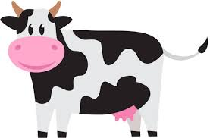
Jokes
Q: What did the cow do at the weekend?
A: She went to the moooooooovies!

Knock, Knock.
Who’s there?
Isobel
Isobel who?
Is a bell really needed on a bike?

Q: Why didn’t Donald Trump speak in the microphone?
A: Bottom fart

Q: What are Crocodile’s favourite game?
A: Snap

COLEGATE NEWS

Superman 2025 review
Superman 2025 is directed by James Gunn
Superman is also known as brace Wayne
Superman has cousin her name is super girl
And known as Kara zor- ei
This movie is tribute to Christopher Reeves

Superman is high grossed $604.5 million worldwide
And superman’s villain is lex Luther I dislike Nicholas houit
I like his actor

This movie came out July 11 2025

David corenswit is great cast as superman
Superman’s cat
Created by Jerry Siegel Jim modney
Air ago streaky
Species cat/ with krypton powers.

David corenswit revealed that Henry Cahill wrote him a letter with support.



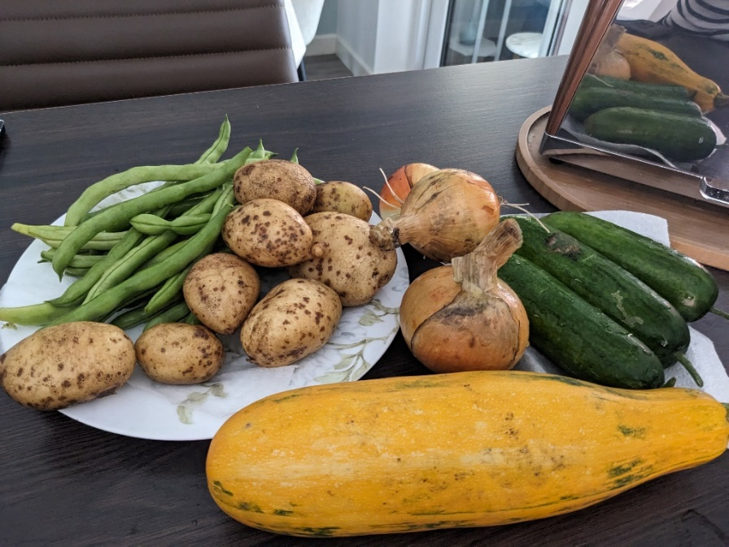
Two photos submitted by one of our members, to show off the lovely vegetables they grew on their allotment at the gardens and what they chose to do with them. Thank you to Thomas for the photos.



COLEGATE NEWS

Air fryer recipe ideas
Air fryer chips
Air fryer baked potatoes
Air fryer cheese toastie
Air fryer roast tomato and pepper pasta
Air fryer cauliflower wings
Air fryer mozzarella sticks
4lngredient air fryer cookies
Easy onion rings
Banana chips

Cooking top tips
Always wash your hands before you start cooking
Use the right chopping board
- Red: meat
- Yellow: cooked meat
- Blue: fish
- White: dairy
- Green: fruit
- Brown: veg
Make sure you hold your knife properly when chopping look at
What you are chopping concentrate
Wash your hands when you touch meat and eggs
Ask for help it you need it

We asked some questions to the Recreating Art group and here’s what they said:
What is your favourite drink?
Coke; Fanta; Diet coke; Hot chocolate; Tea
What is your favourite food?
Fish and chips; Pizza; Crisps; Scampi
What is the best pudding?
Blackberry crumble; Jam roly poly; Chocolate cake; Custard; Colin the caterpillar cake
What is the best takeaway?
Chinese; Brick Pizza; Maccies; fish and Chips; KFC
What’s the best meal to cook at home?
Burritos; Pizza; Roast chicken; Kebabs; fish and Chips

The group also let us use some of their fantastic pictures so stay tuned for those

COLEGATE NEWS

Dear Aunt Patsy
- My friend keeps involving me in their relationship problems, and I don’t want to be involved. I feel like piggy in the middle.
  - Sit down and talk to your friend nicely and calmly. Tell them it is between them and how it makes you feel and ask them to stop involving you. If it doesn't help, ask someone you trust to talk it through with you.

- Someone I know is being rude to everyone around them and does not speak nicely. What should I do?
  - Be kind to the person, even if they are being rude- they might be having a bad time, or they might be tired. Try and be understanding. Ask them privately why they are being rude if you feel like you can, or walk away if you need to.

- My friend keeps telling lies. Should I try and help him or stop being friends?
  - How serious are the lies? It's it hard to trust someone who tells lies. So, it may be easier to switch off and ignore them. If they are telling lies that could hurt someone, tell someone you trust to help you sort it out. They could be stressed or have something on their mind, but telling lies can be very serious.

- I want to know how to be more helpful to my friend who has a wheelchair when we are out and about.
  - Help out with the small things. Offer to hold doors for him/her, let them go before you, offer to go in the lift instead of using the stairs. Sympathetic with you friend. Make your friend comfortable if they feel embarrassed by being kind and making sure you still have fun. Treat them the same-like a friend.

- My housemate has dementia and she gets confused and forgets things. People are sometimes rude to her. How can I be a more supportive friend?
  - That must be very difficult for her. Be kind to her even when other people are not. Be a good friend and try and be understanding when she is confused. Make her feel included in the activities you are doing so she doesn’t feel left out.


Ask Aunt Patsy…

COLEGATE NEWS

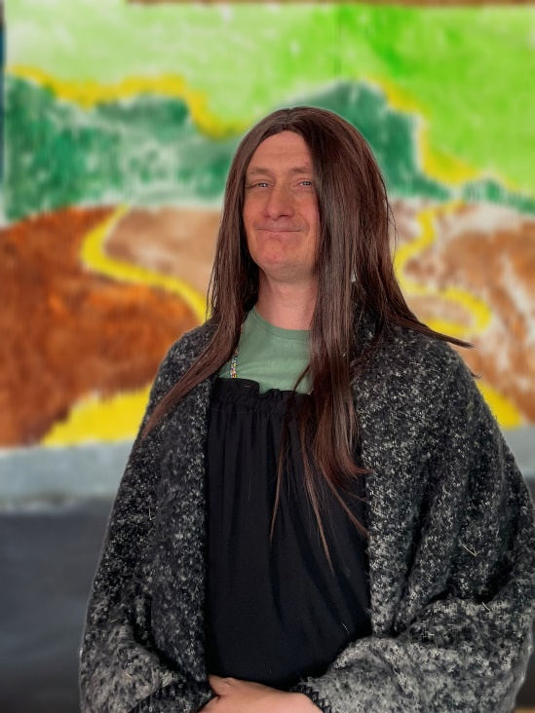





The Recreating Art group spent their time recently working hard on making the Mona Lisa. Thanks for letting us share them with the world, Hannah, Joe, Stefan and Kim.

COLEGATE NEWS

Quiz
- Who turned up in EastEnders on the 22nd September out of the blue?

- Which Neighbours actor is in Strictly Come Dancing?

- What is ‘pants’ in American English?

- What pub do Del Boy and Rodney go to in Only Fools and Horses?

- How many Star Wars films are there?

- Who is the father to Zoe Slater’s twins?

- What is the longest running soap on TV?

- How do you score 180 on a darts board with only three darts?

- How many players are in a basketball team?

- What year did Norwich City win the Milk Cup?

- Who painted the Mona Lisa?

- What are the names of the current presenters of The Great British Bake Off?

- How many Harry potter books are there?

- How do you make a latte?

- What is the name of a group of giraffes?


How many did you get right?

/15

Answers on last page…

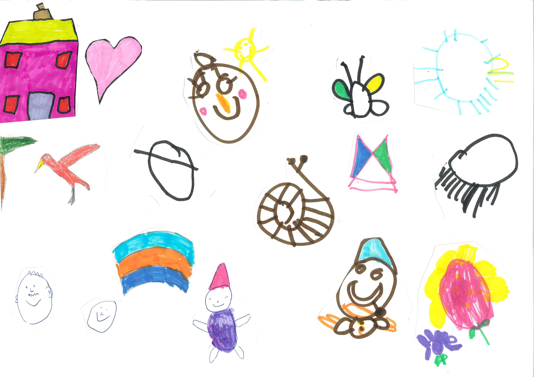
COLEGATE NEWS

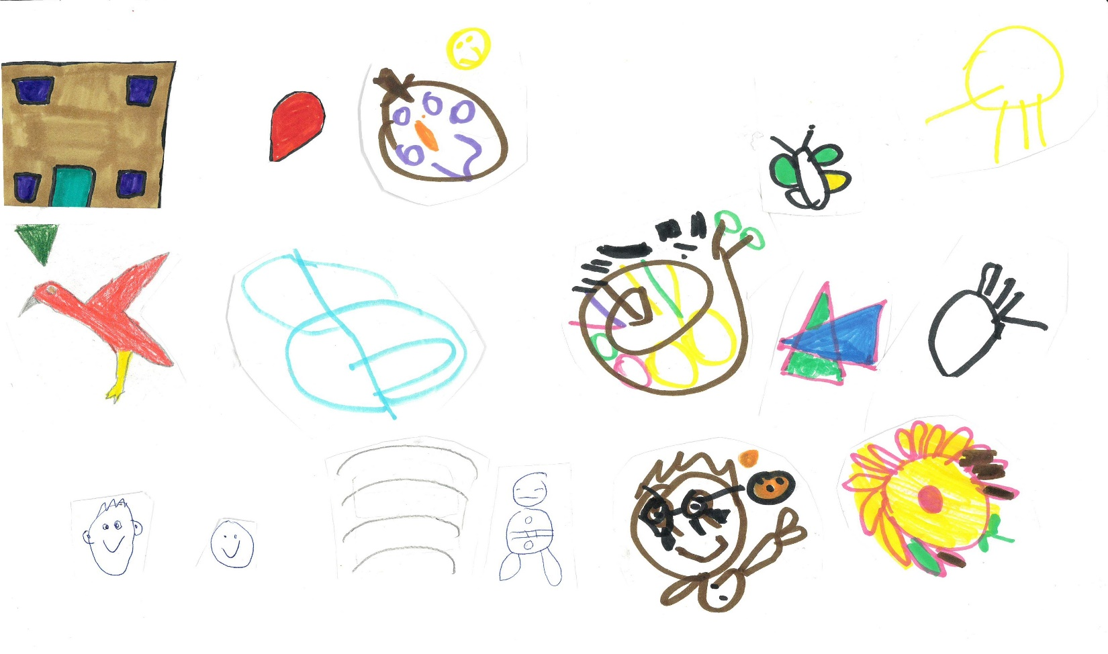
SPOT THE DIFFERENCE
B | U | T | T | E | R | F | L | Y | Z | Y | D | O | G | L | I
G | V | W | A | S | X | T | H | E | X | W | O | V | F | M | S
E | Y | X | H | T | O | L | S | D | V | W | L | Z | F | N | O
R | Z | W | H | T | T | Y | X | E | L | E | P | H | A | N | T
B | K | A | N | G | A | R | O | O | A | Z | H | W | X | A | T
I | Z | Q | S | R | G | T | W | Z | G | L | I | U | Y | L | I
L | P | E | N | G | U | I | N | D | R | A | N | Z | X | L | T
T | Q | N | T | B | E | A | R | B | K | D | Y | N | O | I | L
A | I | Q | I | S | D | L | M | X | C | Y | M | D | B | R | I
K | L | G | D | Q | Z | A | N | O | O | B | A | B | Y | O | X
R | D | P | E | G | T | O | P | Q | C | I | A | D | Y | G | Y
E | L | S | R | R | Z | K | W | S | A | R | V | X | Q | V | W
E | O | T | C | O | X | Y | X | V | E | D | W | Q | R | U | Z
M | O | N | K | E | Y | D | H | I | P | P | O | Z | P | Y | O

Koala
Hippo
Bear
Dolphin
Monkey
Kangaroo
Elephant
Meerkat
Penguin
Tiger
Peacock
Seal
Sloth
Gorilla
Lion
Rabbit
Butterfly
Baboon
Ladybird
Gerbil
Dog

COLEGATE NEWS

TV fun facts:
- The first ever advert on TV was Gibbs toothpaste, 70 years ago

- The first presenter of Good Morning Britain was John Stapleton

- Strictly Come Dancing first came on TV in 2004

- The names of the animals on Rainbow are Zippy, George and Bungle

- The first winner of I’m a Celebrity was Tony Blackburn

- The First Dr Who was William Hartnell

- The Bill on BBC started in 1984 and ran until 2010

Quiz answers:
- Sharon Watts
- Paul Robinson (Stefan Dennis)
- Trousers
- Nag’s Head
- 12
- Dirty Den Watts
- Coronation Street
- 3 triple 20s
- 5
- 1985
- Leonardo DiVinci
- Noel Fielding and Alison Hammond
- 7
- Milk, espresso, foam
- A tower


Thank you to the whole group for working hard, this has been a fun group for us. We would also like to thank our readers, especially to the people who have put suggestions in our suggestion box.
We hope you all enjoyed reading our articles.

From Anna, Patsy and the Newsletter Group.

