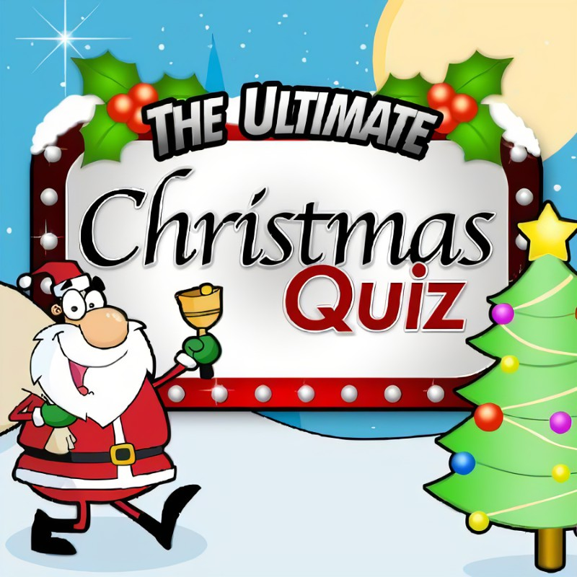
- What colour are mistletoe berries?

2. What was frosty the snowman’s nose made out of?

3. On which date is Christmas celebrated every year?

4. What is scrooge’s first name?

5. When Santa got stuck up the chimney, what did he have in his sack?

6. What dose Santa give to naughty children?

7. Which sauce is traditionally served with Christmas pudding?

8. What sweet snack is typically left out for Santa?

9. what drink is typically left out for Santa?

10. In which tin of chocolate would you find the hazelnut swirl?

- White
- Button
- Dec 25th
- Ebenezer
- Soot
- Coal
- Brandy sauce
- Cookies or minces pies
- Milk
- Cadbury roses

Made by Lyndsey Y

